JBLE-Langley AFB Department of the Air Force

School Liaison Program
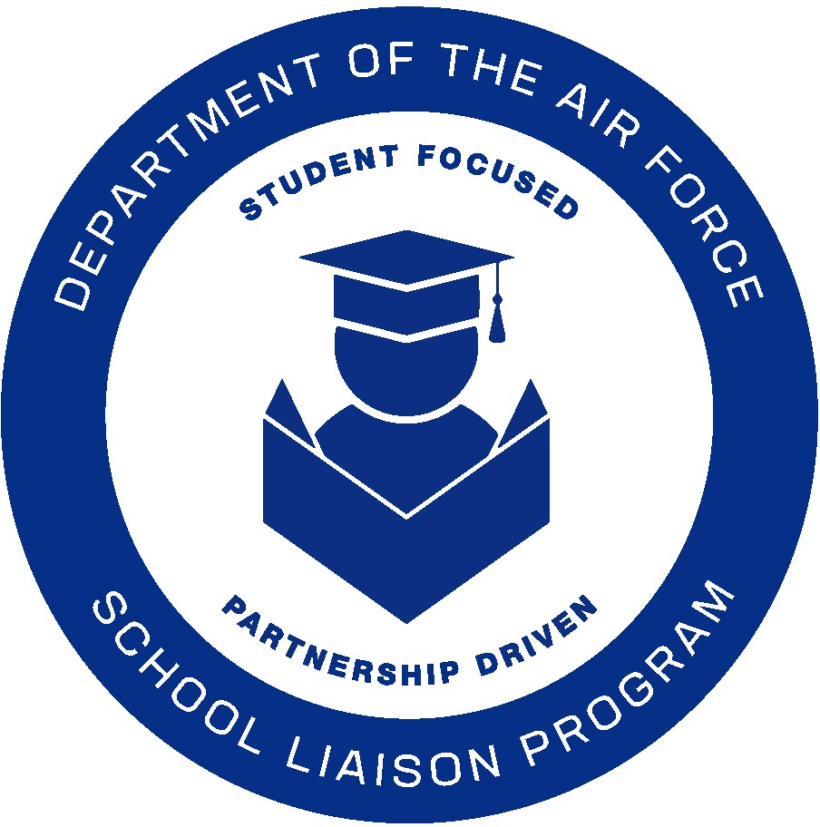

The School Liaisons’ primary function is to serve as a conduit between parents, educators and the command so that military-connected children experience a seamless transition during the transfer between schools. Many military children move an average of every 2.9 years, School Liaisons can provide families with information to assist them as they begin their PCS planning.

The DAF School Liaison Program support military families in collaboration with the installation, schools, and the community through the following core focus areas:

Core Focus Areas

Education Community Partnerships - Community Relations, Partnerships, and Outreach: Facilitate a network of parents, military/civilian personnel, and community partners to support educational needs of military-connected youth. Responsible for Education Community Partnerships on and off the installation.

Installation, School, and Community Communications: Serve as installation subject matter expert (SME) to Commander/Command Staff/parents for all local Pre-K-12 issues regarding military child education. Develop connections and partnerships between organizations providing services to students, school personnel, and the community.

Transition Support: Help facilitate solutions for transitional issues (e.g., PCS/PCA, moving off/on the installation, deployment, childcare to Pre-K/K, Elementary School to Middle School, and Middle School to High School) affecting military-connected students.

Deployment/Parental Absence Support (TDYs, Remote, etc.): Provide families and school personnel resources focused on coping with parental absence, to include the cycle of deployment and minimizing negative academic, social, and emotional impact.

Home School Support: Share information on homeschool issues, concerns, local policies, and regulations of state/local education agencies regarding homeschooling as well as connecting home school families to their community.

Special Education Navigation: SLs help families navigate special education local education policies, and work collaboratively to connect LEAs to resources and supports empowering families to successfully navigate the continuous improvement process based on the student’s individual need.

College, Career and Military Readiness - Academic Planning and Postsecondary Preparations: SLs leverage installation/school resources to provide military students' access to postsecondary information and opportunities.

Educator’s Professional Development (PD): SLs provide opportunities for educators PD to enhance their knowledge of military-connected students’ needs and requirements.

Military Interstate Children’s Compact Commission (MIC3) Compliance: SLs are the first step in the chain of command for both schools and families regarding the MIC3 and state compliance.
Scholarship & Grant Opportunities: SLs provide resources for schools and families to enhance their educational opportunities and goals.

Public School Information

Please note: In Virginia, your physical address determines the schools your children will attend.

JBLE-Langley School Liaison supports the following school divisions:

Hampton City Schools (HCS) http://www.hampton.k12.va.us/
Poquoson City Public Schools (PCPS) https://www.poquoson.k12.va.us/

York County School (YCSD) https://yorkcountyschools.org/

Enrollment/Registration
Hampton City Schools
http://www.hampton.k12.va.us/registration/registration.html
Poquoson City Public Schools
https://www.poquoson.k12.va.us/families/student-registration

York County School (YCSD)
https://yorkcountyschools.org/parents/enrollment/default.aspx

Private School information

There are many private school options in the Hampton Roads area which include, but are not limited to Montessori, Religiously Affiliated, and Special Education.

Virginia Council for Private Education (VCPE)
http://www.vcpe.org/

Private School Review https://www.privateschoolreview.com/

Home School Information
Parents interested in home schooling their children should be aware that the state of Virginia requires notification of the intent to home school.
Virginia Department of Education Home Instruction
http://www.doe.virginia.gov/families/private_home/index.shtml
Home Educators Association of Virginia
http://heav.org/
Organization of Virginia Homeschoolers
http://vahomeschoolers.org/

PreK-12 Special Needs

Parents of special needs students can connect with their local public school’s Parent Resource and Information Center:
Hampton City Schools Special Education Services
https://sites.google.com/hampton.k12.va.us/hcs-sped-family-resources/home
Poquoson City Public Schools Student Services
https://www.poquoson.k12.va.us/departments/special-education-student-services

York County Schools Special Education Services https://yorkcountyschools.org/parents/specialEducation/services.aspx
Parent Educational Advocacy Training Center (PEATC)
https://peatc.org/
Military OneSource (resources for families with special needs).
https://www.militaryonesource.mil/confidential-help/specialty-consultations/special-needs-consultations/
Specialized Training of Military Parents (STOMP)
http://wapave.org/
Parents’ Guide to Special Education
http://www.doe.virginia.gov/special_ed/parents/parents_guide.pdf
Guidance for Military Families with Students in Special Education
http://www.doe.virginia.gov/special_ed/parents/military_families_sped_guidance_.pdf

Exceptional Family Member Program (EFMP)

Exceptional Family Member Program (EFMP) Liaisons are located at Military and Family Readiness Centers (MFRC) and provide information and referral to help EFM families identify and access appropriate military, national and community resources. They assist in the navigation of EFMP related programs and systems and are responsible for:

- Provision of information, referral, and systems navigation to special needs families
- Linking families with available military, national and local community resources

- Non-medical case management
- Development and maintenance of Individualized Service Plans (ISP)
- Partner with Military Treatment Facility (MTF) Coordinators to provide information, education, and marketing

Youth Sponsorship
The Youth Sponsorship program is designed to assist young people in making the transition from one installation to another successfully. It is our goal to help incoming youth adjust and get connected with a youth sponsor at the installation. Youth Sponsors will provide information about area schools, attractions, and the surrounding community. This program is created by and for youth with youth involvement in every aspect of the program. To apply for a youth sponsor please contact the Youth Center for more information at 757-225-2605.

Resources

Online Tutoring Resource (Academic Support)
http://www.tutor.com/military
SAT/ACT Preparation
http://www.eknowledge.com/allAccessLandingPage.php?coupon=3A8E9CEFCE
Free Application for Federal Student Aid (FASFA) https://studentaid.gov/
Department of Defense Education Activity (DoDEA)
https://www.dodea.edu/
Military School Liaisons (All branches)
https://www.dodea.edu/Partnership/schoolLiaisonofficers.cfm
Interstate Compact on Education Opportunity for Military Children
http://www.mic3.net/
Military Child Education Coalition (MCEC)
http://www.militarychild.org/
National Military Family Association (NMFA)
http://www.militaryfamily.org/
Military OneSource (MOS)
http://www.militaryonesource.mil/

